|  |  |
| --- | --- |
| **Function Call** | **Result** |
| SUBSTR(CONCAT(‘HIGH’, ‘SALARY’), 4, 6) | HSALAR |
| CONCAT(SUBSTR(‘INFORMATION’, 3, 4), ‘TECH’) | FORMTECH |
| INSTR(CONCAT(‘GET’, ‘ING’), ‘TIN’) | 3 |
| ROUND(69.476, 1) | 69.5 |
| TRUNC(’13-MAR-90’, ‘MONTH’) |  |
| TRUNC(’13-MAR-90’, ‘YEAR’) |  |
| MOD(90, LENGTH(‘SEVENTY’)) |  |
| MONTHS_BETWEEN(’14-AUG-96’, ’23-MAR-95’) |  |
|  |  |
|  |  |

**Task 1:**

**Task 2:**

(1)

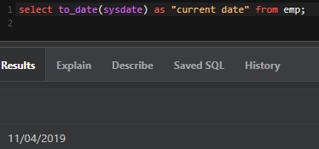

(2)

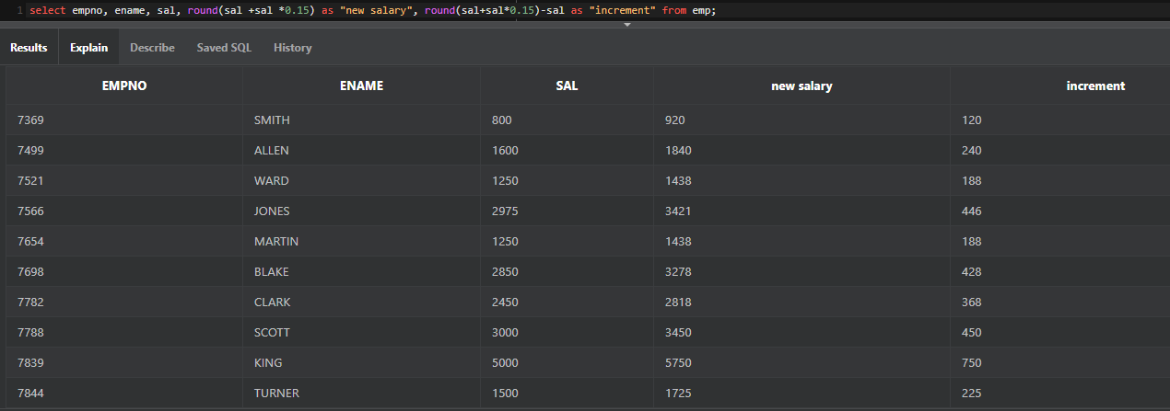

(3)

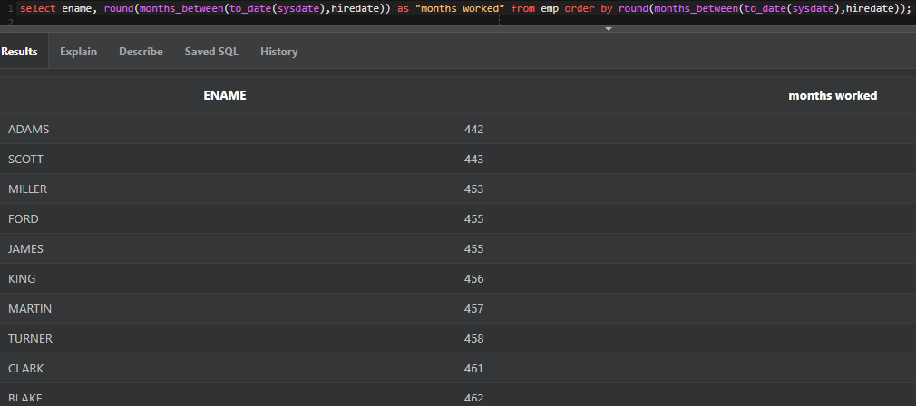

(4)

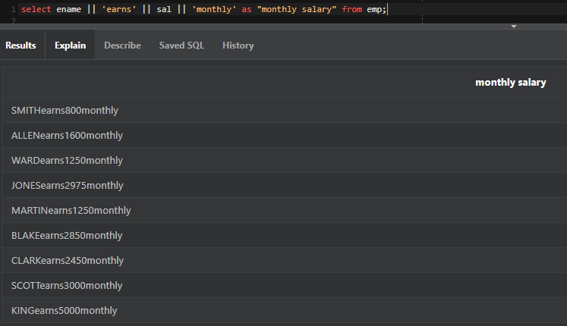

(5)

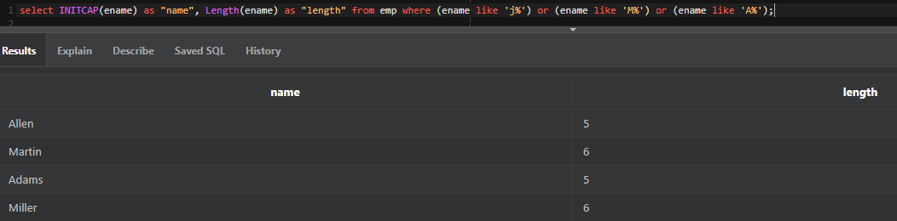

(6)

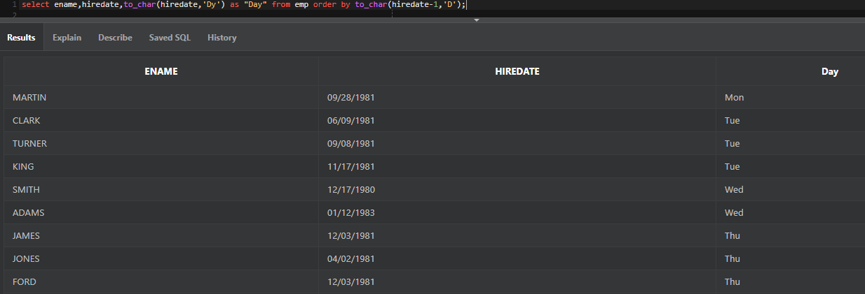

(7)

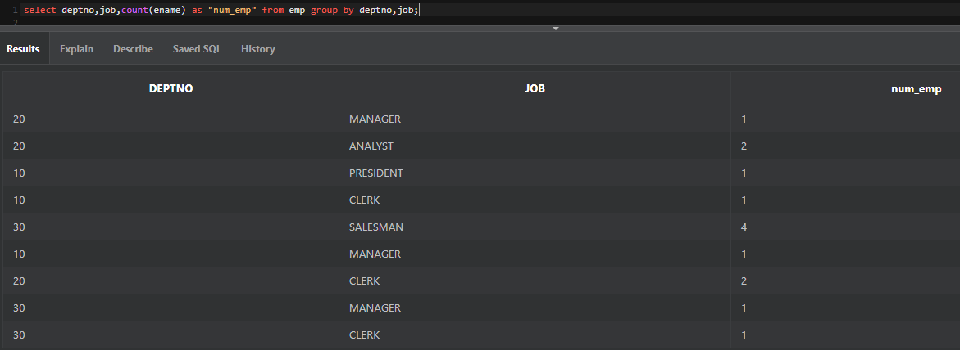

(8)

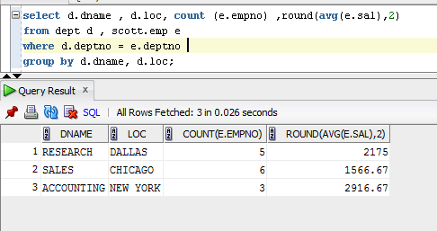

(9)

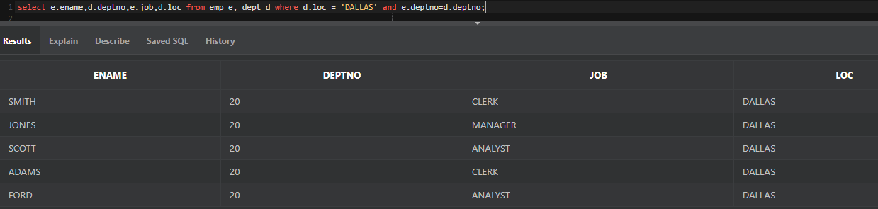

(10)

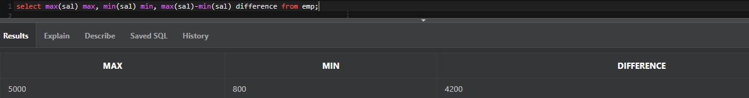

(11)

